Requested corrections in the software

- What is Asset Code? – This can be converted to Non mandatory RFID code (for adding later if required).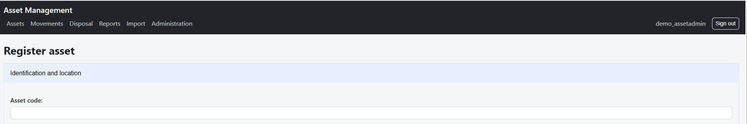
- After Asset Code field, insert the “Type of inventory” as drop down list – PIR / DIR / IIR”
- Serial number is given in numeric. It needs to be in auto generated.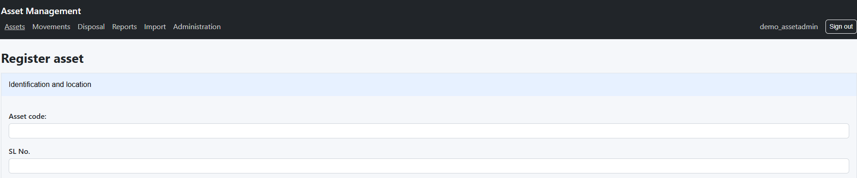
- Transaction id: to be auto generated. The format dd-mm-yyyy followed by auto generated number.
- Calendar to be moved near the date text. Lengthy mouse scrolling should be avoided for smooth user interface.

- Current Status: It should include all these values in the drop-down box.

In stock
Assigned – Instead of “assigned” change it to “issued”
Outside premises
Return pending
Under disposal
Disposed
Written Off
Passed Out
- Accessories to be uploaded as sub part of main item. (for main item computer, accessories like monitor, key board etc. which may have serial numbers separately).

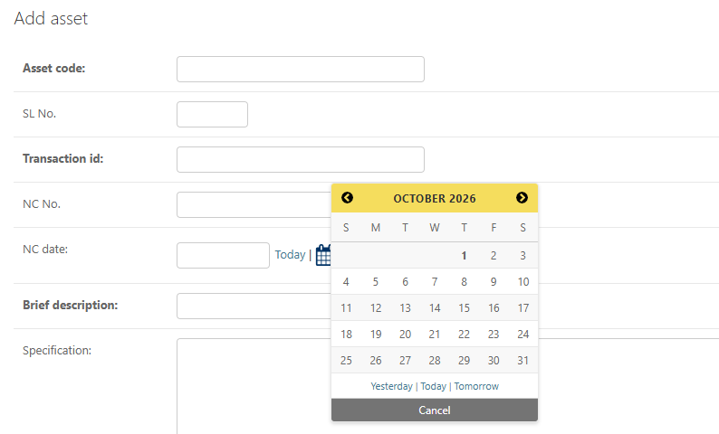

- Change the Calendar navigation as per yearwise.
- Module for sub asset / accessories– Transferring / returning should be possible
- Serial number should be default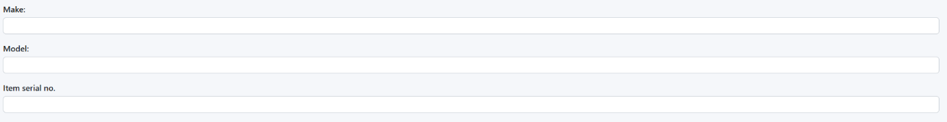

Procurement tab
- Amount/Unit rate
- Bill value must include different currencies like dollar, euro and yen in addition to rupee
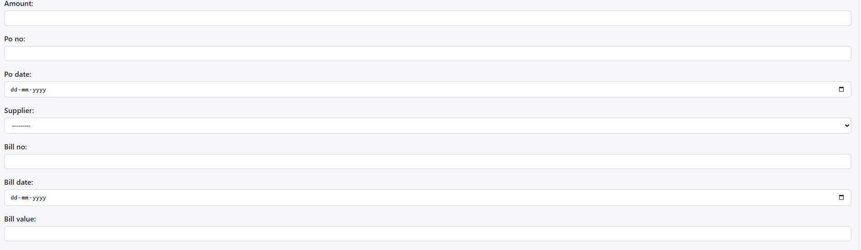
- Insert the following fields
DRR No.
DRR Date
GRIN No.
GRIN Date

Stock and Installation tab
- Status of Assets – working or not working as drop-down list
- Column should be provided whether Log book is maintained or not – yes or no value to be given in that column.
Types of movement:

- Transfer asset – to search in google type search bar can be given instead of choosing from list.
- Display asset details – details to be displayed
Centre – It includes RCED Kolkata, Kanpur, Jalandhar and Ahmedabad.
Building – When building and room changes, the movement should capture it.
Other than simple name change, the asset movement should include;
- PIR/DIR change
- Division change
- Location change
- name change
- Instead of the nomenclature “Movement date”, “transferred date” should be used

Disposal

- Stores return tab:
Surplus/obsolete/unserviceable
- Return to lot classification function should be given to stores section only.
- Instead of create proposal – save to be changed
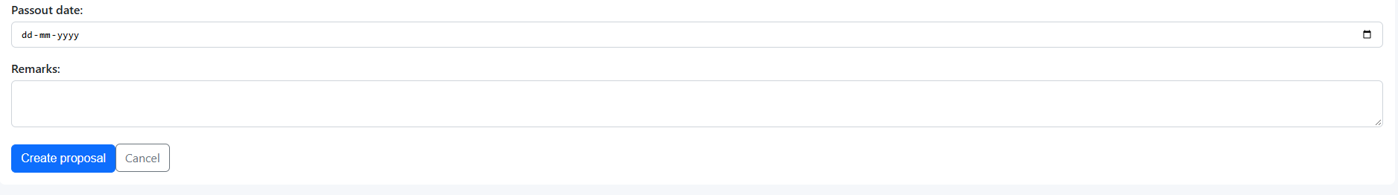

- Main Modules – Asset adding, Transfer of Assets, Return of Assets, verification of assets(whether items are available or not available).
Fields for return of assets module:
RETURN (YES/NO)
RETURNED_STOCK
RETURN_FROM_NAME
RET_VOUCHER_NO
RETURN_VOUCHER_DATE
RETURN_CLAUSE - Surplus/obsolete/unserviceable (Give these as values in drop-down box)

RETURN_FROM_DIVISION

Import module template will be given, and it must be the template for all future uploading.
Gate pass: It should show items only registered on his/her name or division. Search box(searching only with their division) must be provided to choose from it. Reject option must be provided for gate pass approval for both division admin and stores admin.
Mark outward/ inward should be given only to security admin so that they can mark items which left the campus.

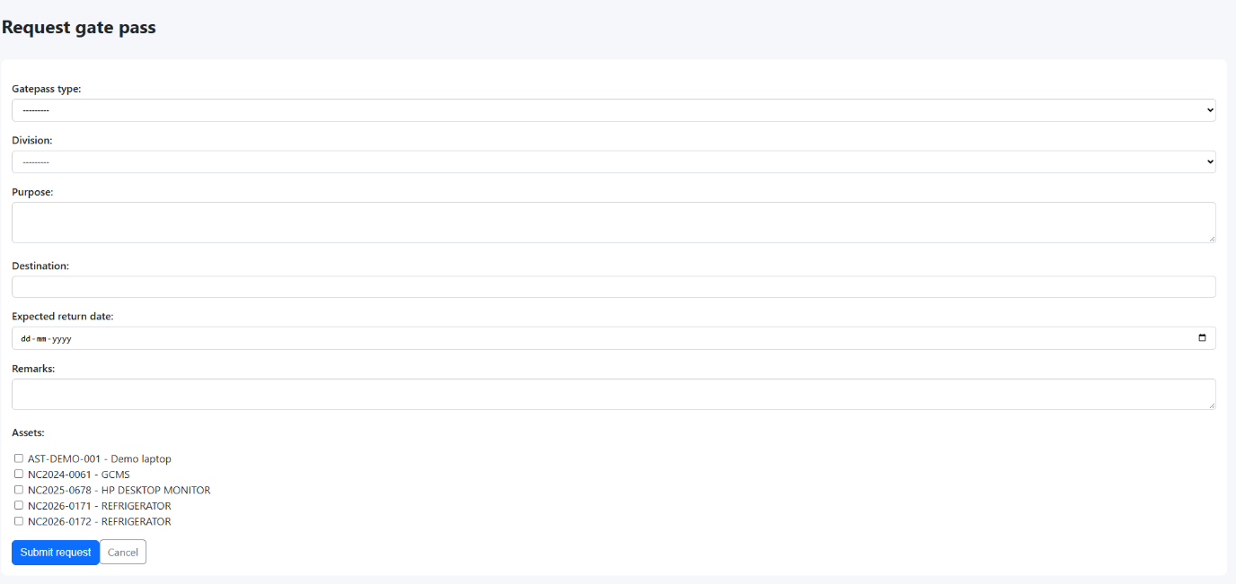

Employee master
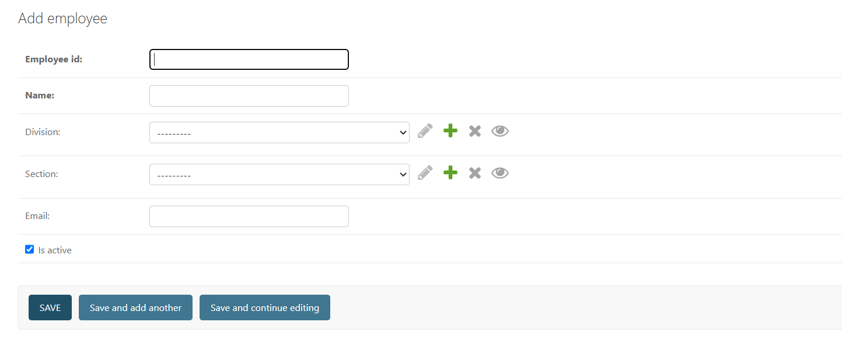

In addition to above fields, Date of Joining and Date of Retirement needs to be added.

Location master

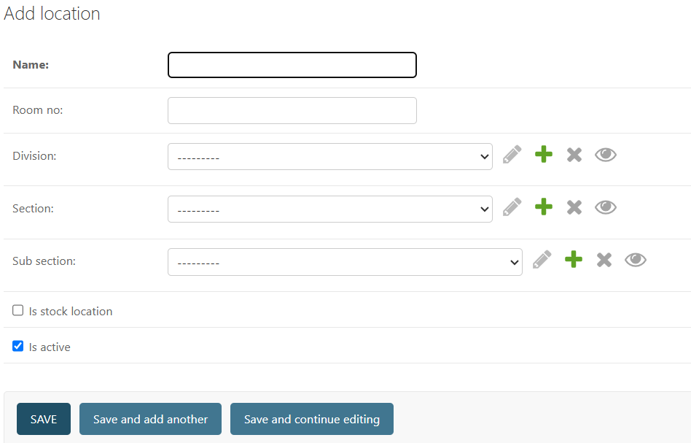

- Instead of Name, change as Current Location. It must contain these values as separate drop-down box- Current place / location.

- Room No. field also drop-down box instead of text.

- Include the Building Name as drop-down box.

The following masters has to be included in the Core:

Budget Master
Budget classification
Project Code

Report Generation: Include reports generated from the dates given by user. Give date option.
Verification of assets report
View PIR/DIR – reports should be available in the following manner: based on employee name, division-wise name, room-wise, location wise.

